Screen 1 (scrollable)

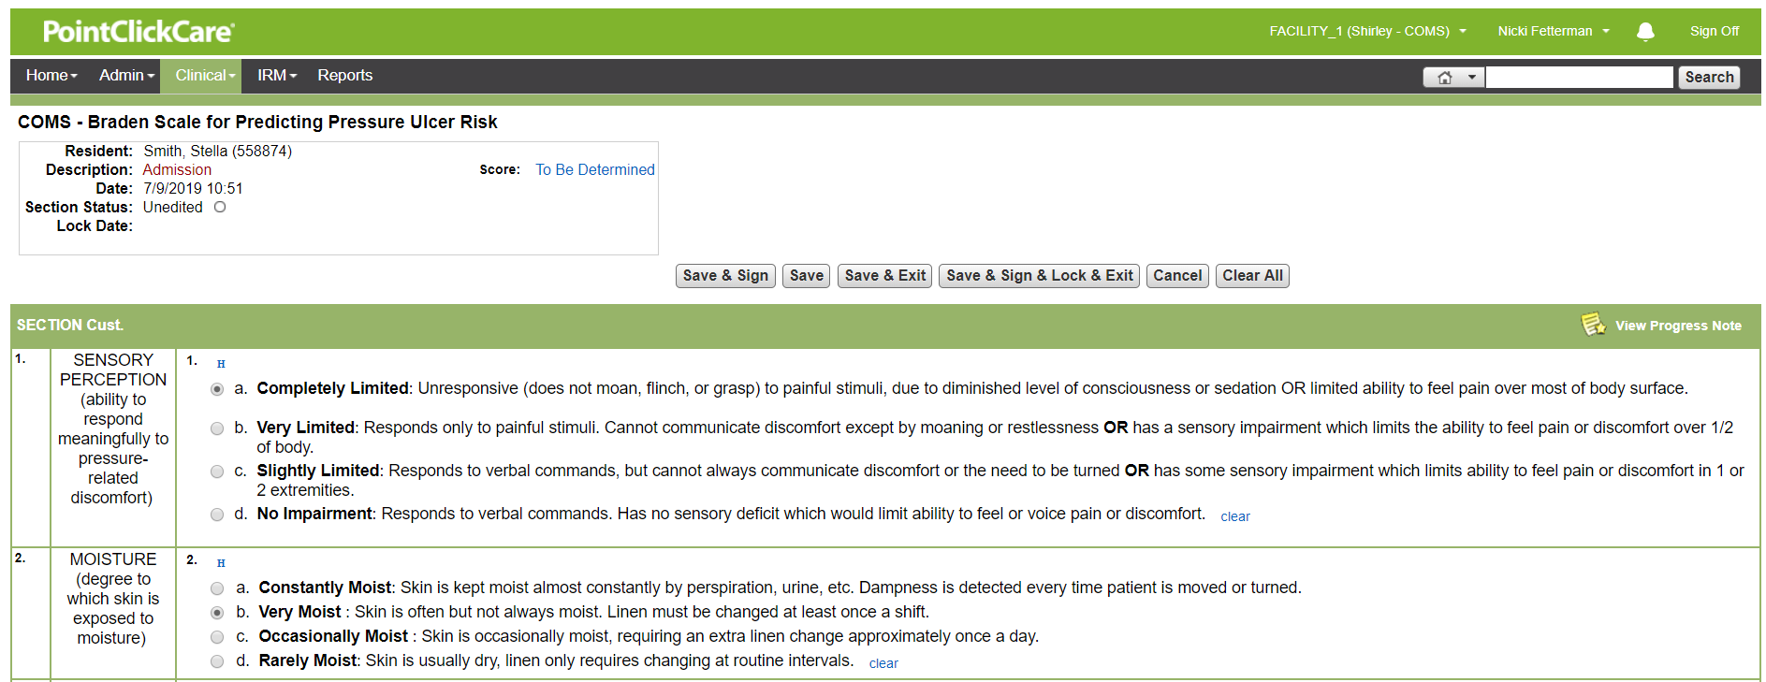

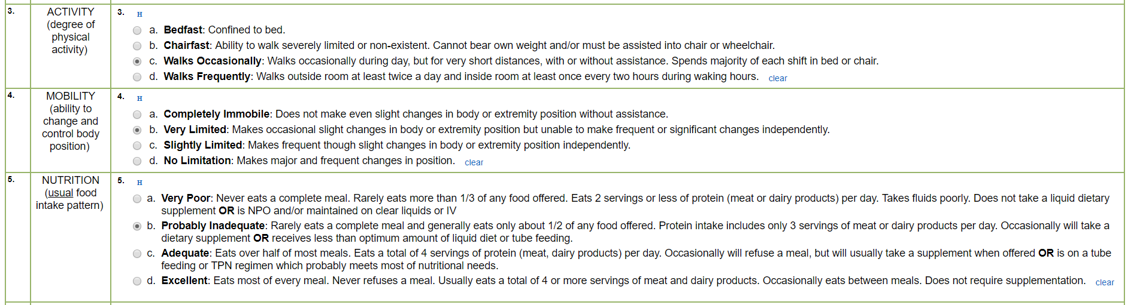

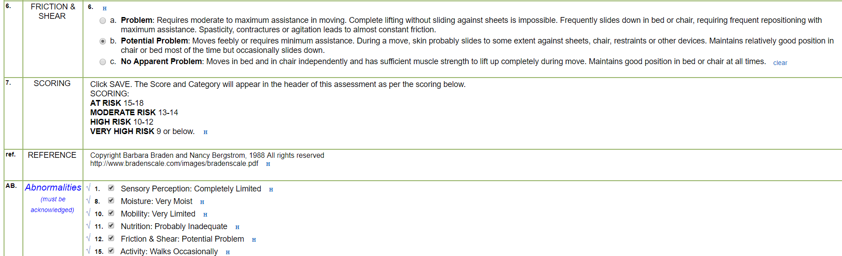

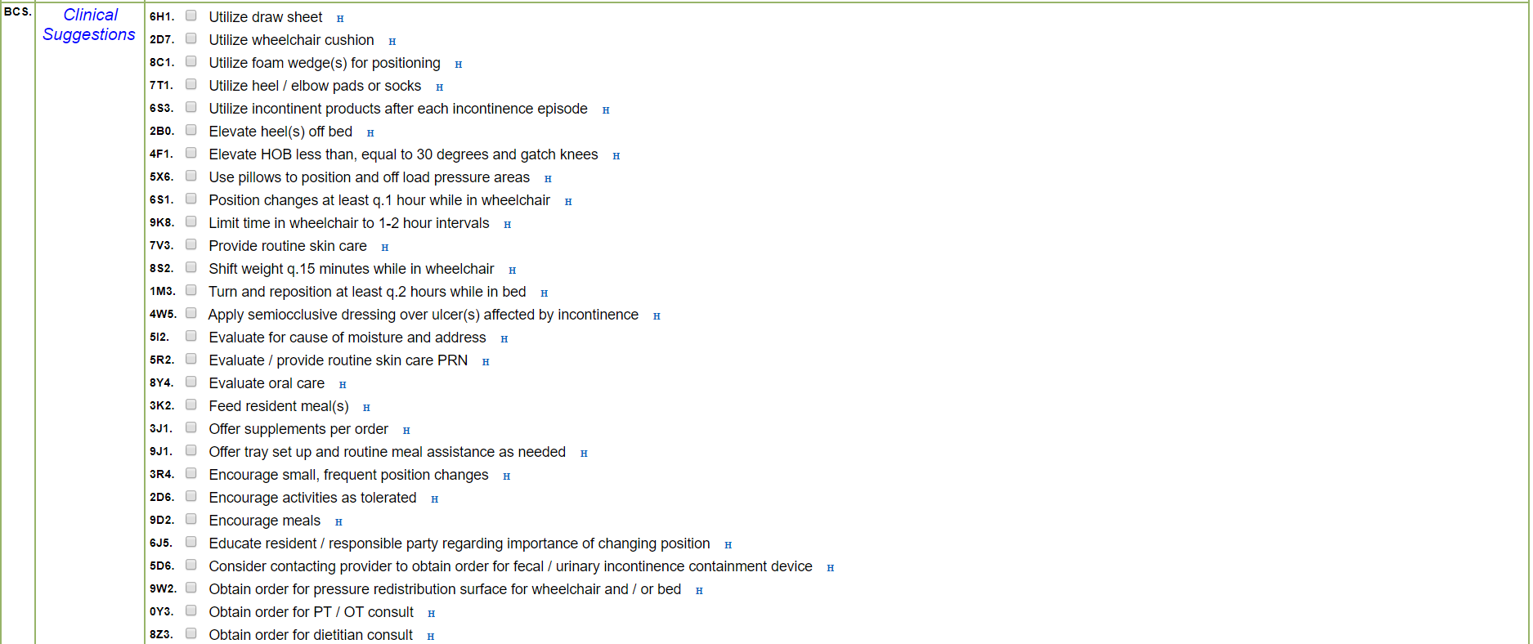

Then scroll back to top. And outline the save button when area is touched.

Screen 2

No need to scroll the entire length. The focus is top of page.